Inclined Great Circle
# Source: AI Source: Provided by: [Data Path: Persons Table -> ID Column: 1, Name_En Column: Motasem Essam] -> From: [ChatGPT] on [7/25/2026]
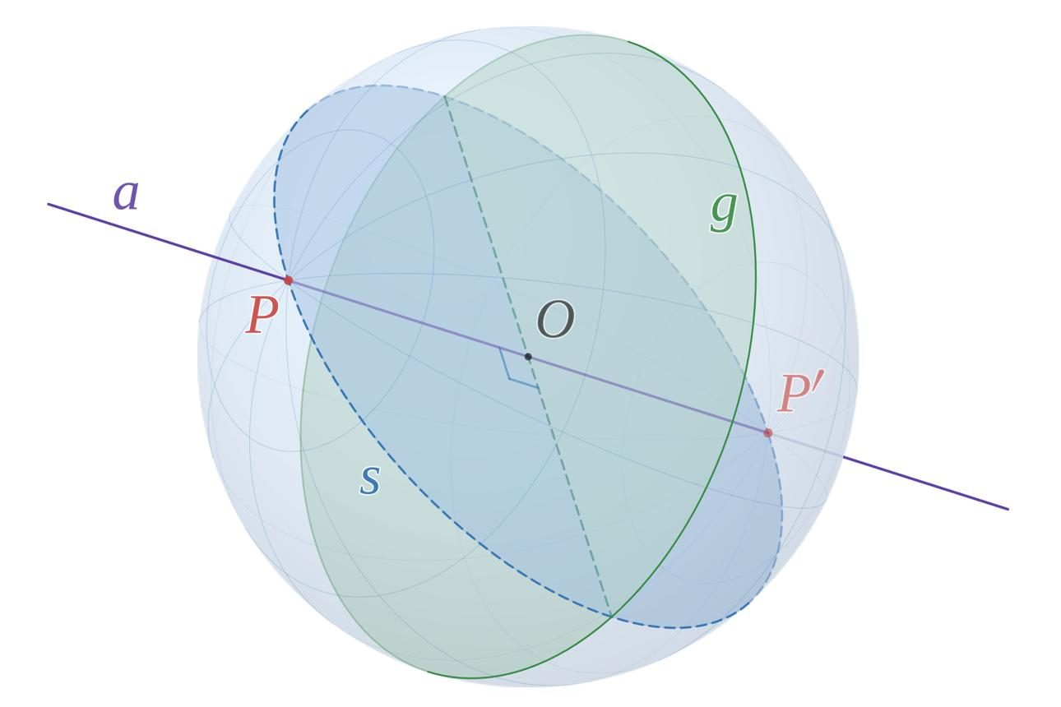

Definition
# Source: AI Source: Provided by: [Data Path: Persons Table -> ID Column: 1, Name_En Column: Motasem Essam] -> From: [ChatGPT] on [7/25/2026]
An inclined great circle is a great circle formed by the intersection of a sphere with a plane that passes through the sphere’s center and is inclined to a chosen reference plane or axis.
Like every great circle, an inclined great circle has the same radius as the sphere and divides the sphere into two equal hemispheres. The word inclined describes its orientation relative to a reference direction, not a different kind of circle.
Important: The inclination must be measured relative to a specified reference plane or axis. Without that reference, the term inclined great circle does not determine a unique orientation.

Simple Definition
# Source: AI Source: Provided by: [Data Path: Persons Table -> ID Column: 1, Name_En Column: Motasem Essam] -> From: [ChatGPT] on [7/25/2026]
An inclined great circle is a circle drawn around a sphere by a plane passing through its center at an angle to a chosen reference plane.
For example, imagine slicing a globe through its center with a flat plane tilted relative to the equatorial plane. The circular intersection is an inclined great circle.

Geometric Characteristics
# Source: AI Source: Provided by: [Data Path: Persons Table -> ID Column: 1, Name_En Column: Motasem Essam] -> From: [ChatGPT] on [7/25/2026]
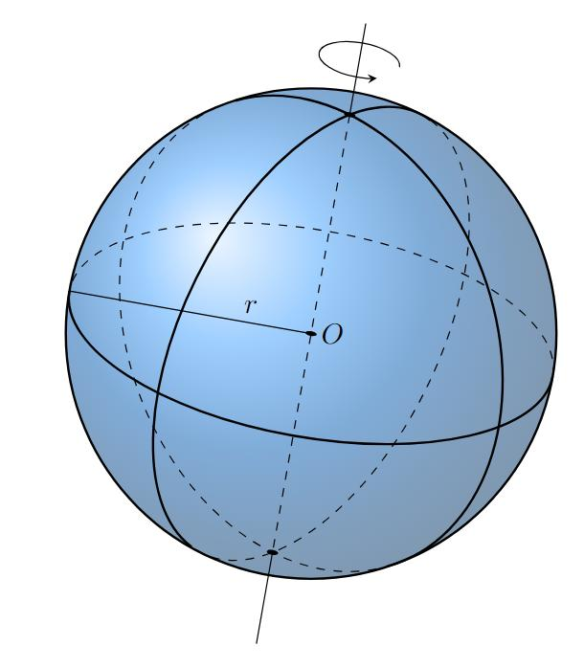
An inclined great circle has the following characteristics:
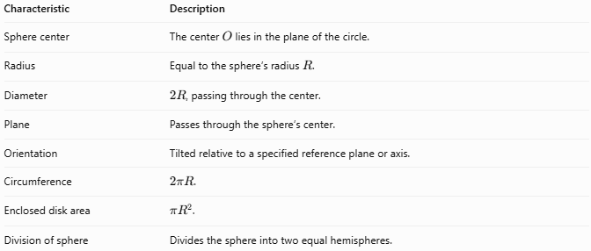
Characteristic | Description
Sphere center | The center $O$ lies in the plane of the circle.
Radius | Equal to the sphere’s radius $R$.
Diameter | $2R$, passing through the center.
Plane | Passes through the sphere’s center.
Orientation | Tilted relative to a specified reference plane or axis.
Circumference | $2πR$.
Enclosed disk area | $πR^{2}$.
Division of sphere | Divides the sphere into two equal hemispheres.

Mathematical Representation
# Source: AI Source: Provided by: [Data Path: Persons Table -> ID Column: 1, Name_En Column: Motasem Essam] -> From: [ChatGPT] on [7/25/2026]
Consider a sphere centered at the origin with radius $R$.
Sphere equation
$$x^{2}+y^{2}+z^{2}=R^{2}$$
Let the equatorial plane be the $xy$-plane:
$$z=0$$
An inclined plane rotated by an angle $θ$ from the equatorial plane about the $x$-axis can be written as
$$z=y\tan{θ}$$
The inclined great circle is the intersection of this plane with the sphere.
Substituting the plane equation into the sphere equation gives
$$x^{2}+\frac{y^{2}}{\cos^{2}{θ}}=R^{2}$$
together with $z=y\tan{θ}$. Although this equation may look elliptical when viewed in the $xy$-coordinate projection, the actual intersection in the inclined plane is a circle of radius $R$.
A convenient three-dimensional parameterization is
$$\begin{aligned}x&=R\cos{t} \\ y&=R\cos{θ}\sin{t} 0≤t<2π \\ z&=R\sin{θ}\sin{t}\end{aligned}$$
Here, $θ$ is the angle between the inclined plane and the equatorial plane.

Important Formulas
# Source: AI Source: Provided by: [Data Path: Persons Table -> ID Column: 1, Name_En Column: Motasem Essam] -> From: [ChatGPT] on [7/25/2026]
For a sphere of radius $R$:
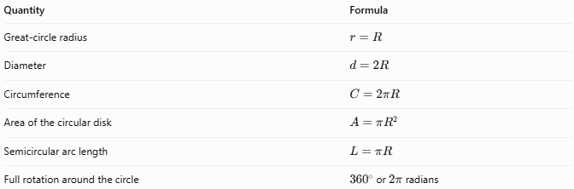
Quantity | Formula
Great-circle radius | $$r=R$$
Diameter | $$d=2R$$
Circumference | $$C=2πR$$
Area of the circular disk | $$A=πR^{2}$$
Semicircular arc length | $$L=πR$$
Full rotation around the circle | ${360}^{∘}$ or $2π$ radians
The inclination angle changes the circle’s orientation, but does not change its radius, circumference, or area.

Worked Example
# Source: AI Source: Provided by: [Data Path: Persons Table -> ID Column: 1, Name_En Column: Motasem Essam] -> From: [ChatGPT] on [7/25/2026]
A sphere has a radius of $8\text{ cm}$. An inclined plane passes through its center and forms an angle of ${40}^{∘}$ with the equatorial plane.
Find the radius and circumference of the inclined great circle.
Step 1 — Radius
Every great circle has the same radius as the sphere.
$$r=R=8\text{ cm}$$
Step 2 — Circumference
$$C=2πR=2π\left(8\right)=16π$$
$$\boxed{C≈50.27\text{ cm}}$$
Conclusion: The inclined great circle has a radius of $8\text{ cm}$ and a circumference of approximately $50.27\text{ cm}$. The ${40}^{∘}$ inclination changes only its orientation.

Comparison with Other Great Circles
# Source: AI Source: Provided by: [Data Path: Persons Table -> ID Column: 1, Name_En Column: Motasem Essam] -> From: [ChatGPT] on [7/25/2026]
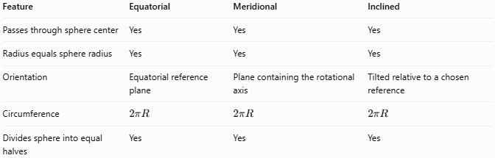
Feature | Equatorial | Meridional | Inclined
Passes through sphere center | Yes | Yes | Yes
Radius equals sphere radius | Yes | Yes | Yes
Orientation | Equatorial reference plane | Plane containing the rotational axis | Tilted relative to a chosen reference
Circumference | $$2πR$$ | $$2πR$$ | $$2πR$$
Divides sphere into equal halves | Yes | Yes | Yes
Note: These descriptions can overlap. For example, a meridional great circle is inclined relative to the equatorial plane, typically by ${90}^{∘}$. In a general geometry classification, “inclined great circle” is a descriptive orientation rather than a separate mathematical class of circle.

Applications
# Source: AI Source: Provided by: [Data Path: Persons Table -> ID Column: 1, Name_En Column: Motasem Essam] -> From: [ChatGPT] on [7/25/2026]
- Geography: Studying great-circle routes between locations on Earth.
- Navigation: Representing routes that follow a great circle, which gives the shortest surface path between two non-antipodal points on an ideal sphere.
- Astronomy: Describing circles on celestial spheres in different coordinate orientations.
- Three-dimensional geometry: Studying intersections between spheres and planes.
- Engineering and graphics: Representing spherical sections and rotating coordinate systems.

Key Points
# Source: AI Source: Provided by: [Data Path: Persons Table -> ID Column: 1, Name_En Column: Motasem Essam] -> From: [ChatGPT] on [7/25/2026]
- An inclined great circle is the intersection of a sphere and a plane passing through its center.
- Its inclination is always measured relative to a specified reference.
- Its radius equals the sphere’s radius.
- Its circumference is $2πR$, regardless of inclination.
- It divides the sphere into two equal hemispheres.
- A circle that does not lie in a plane through the sphere’s center is a small circle, not a great circle.

Conclusion
# Source: AI Source: Provided by: [Data Path: Persons Table -> ID Column: 1, Name_En Column: Motasem Essam] -> From: [ChatGPT] on [7/25/2026]
An inclined great circle is a great circle whose plane is tilted relative to a chosen reference plane or axis. Its orientation may vary, but its defining properties remain unchanged: it passes through the sphere’s center, has radius $R$, and divides the sphere into two equal hemispheres. It is especially useful when studying spherical geometry, navigation, geography, and three-dimensional intersections.

